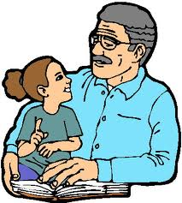
Am I Helping My Child Become A Good Reader?
Building strong reading skills takes practice—more practice than your child can get in school. Here’s a quiz to see if you’re doing what you can to provide reading practice at home. Check off everything you do!

_______1. I read with my child every day.
_______2. I encourage my child to reread favorite books.
_______3. We talk about the books that we read and I ask questions to make sure my child understands what he/she is reading.
_______4. I keep books, magazines, and newspapers around the house so there’s always something to read.
_______5. I know what my child is reading in school and I ask his/her teacher how I can help at home.

How Did You Do?
If you checked all five you’re doing a great job. If not, try the ideas you didn’t check in order to support your child’s reading development at home!

